**OurTool_O**

**OurTool_N**

**QM_N**

**QM_O**

**Sinelabore_O**

**Sinelabore**_N

**EUML_O**

**MSMLite**_O

**MSM**_O

**OurTool**_O

**OurTool_N**

**QM_O**

**Sinelabore_O**

**Sinelabore_N**

EUML_O

**MSMLite_O**

**MSM_O**

execution time (ms) (ms)

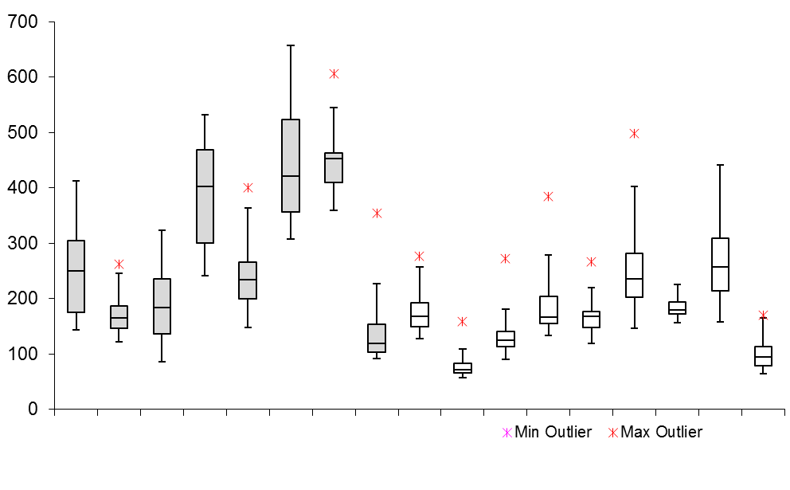

Simple benchmark

Composite benchmark